Mark Lloyd
Chief Executive
Local Government Association
18 Smith Square
Westminster
London
SW1P 3HZ

17 September 2018

Dear Mr Lloyd

Membership of the Local Government Association (LGA)

In my role as Police and Crime Commissioner for Northamptonshire I work closely with local government colleagues within the County and recognise the significant benefits the LGA provides to these organisations. I was, therefore delighted with the LGA decision to offer associate memberships to Police and Crime Commissioners. I can see the benefits increase further as work is currently being finalised to transfer the responsibility for Fire Governance from the County Council to the PCC in Northamptonshire in early 2019.

I should like to take up this offer and should be grateful if you would consider awarding associate membership of the LGA to the Office of the Police and Crime Commissioner for Northamptonshire.

If you require any further information to assist in your considerations, please contact Helen King my Chief Finance Officer at: Helen.King@northantspcc.pnn.police.uk.

Yours sincerely

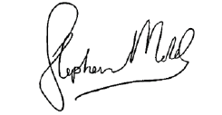

Stephen Mold
Police and Crime Commissioner

